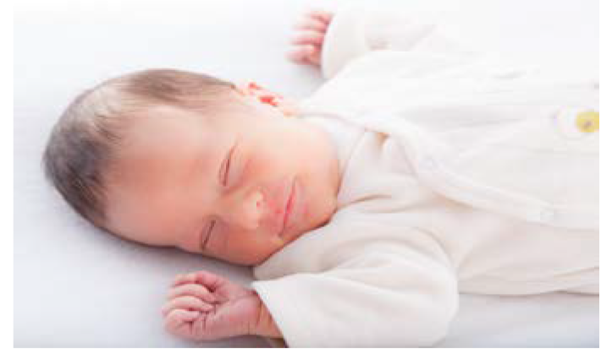 | I have a new baby in the house. I am now a big brother! The new baby will need a lot of help from mommy and daddy. Mommy and daddy will have time for me. It is ok, my mommy and daddy love me a lot.
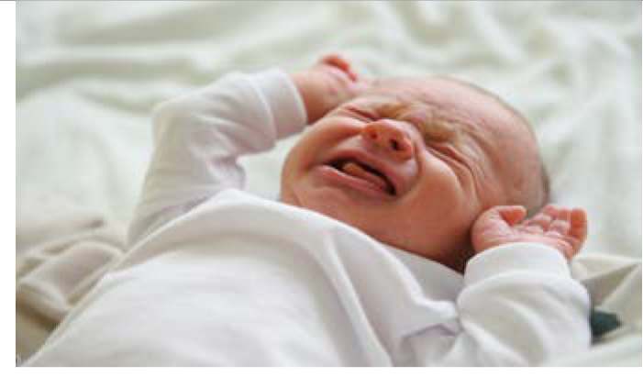 | The baby will cry very loudly a lot. This may hurt my ears or make me upset. Mommy or daddy will need to help the baby. I can cover my ears with my hands, go to a different room, or play with my favorite toys until the baby is quiet.
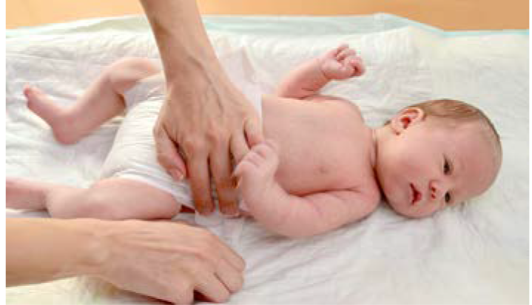 | Mommy or daddy will need to change the baby’s diaper. Sometimes diapers smell really bad. It is ok, I can cover my nose with my hand. Then it will not smell so bad.
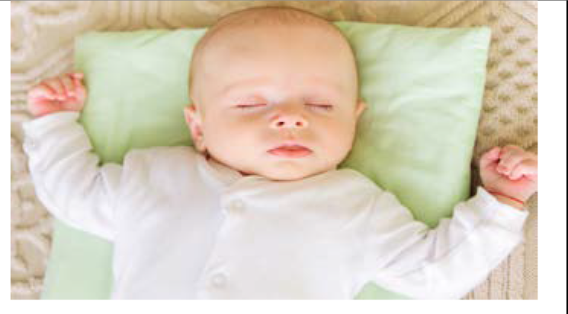 | The baby will sleep. When the baby sleeps, I will be quiet. When the baby sleeps mommy or daddy can play with me. I will have fun!
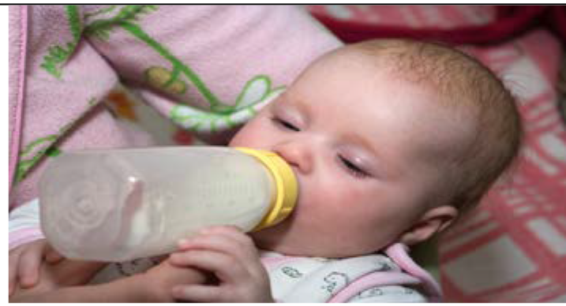 | The new baby will be hungry! Mommy or daddy will feed the baby milk many times in the day. I can sit next to mommy or daddy and the baby or play with my toys.
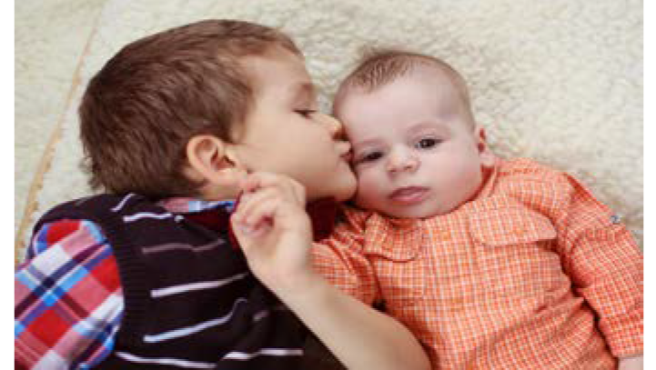 | The new baby is helpless and fragile. I will be very gentle when I touch the baby. My mommy and daddy love the baby. My mommy and daddy love me a lot! I will be a good big brother!

