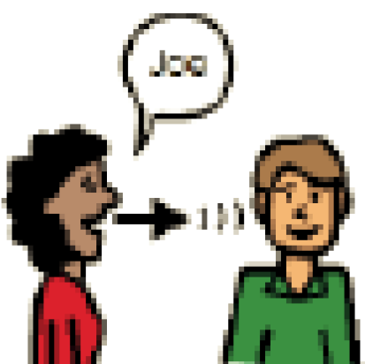 | Look at the person and use their name.
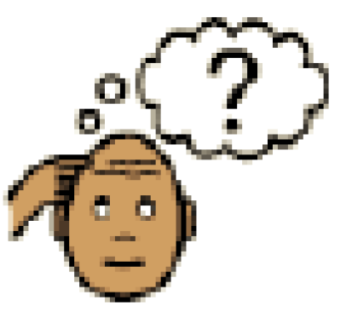 | Ask yourself if this is a good time to make a request.
 | When the answer is “no” to a request just say “Ok”.
 | Listen to the person’s reasons.

 | Stay calm and keep a natural expression.
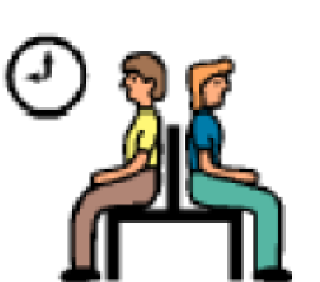 | If you disagree, wait for another time to express your point of view.
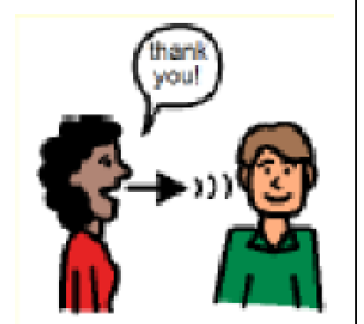 | Thank the person for considering your request. Sound sincere.
 | Listen to the person’s reasons.

