Addition
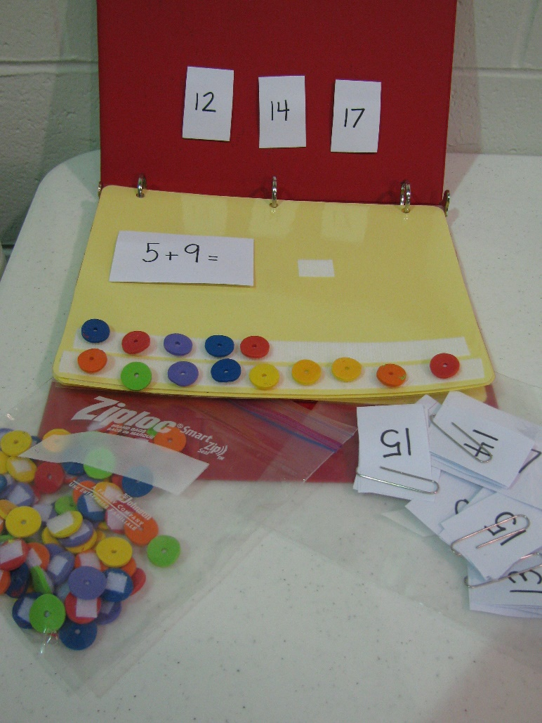

Structured Tasks
Description: Index cards with math problems are placed on each page within a binder. Possible answers are velcroed above.
Fabric shapes are placed on Velcro strips at bottom of each page for student to count to get their answer. Student pulls off answer and sticks it next to the problem.
Baggies with extra problems, answers and shapes mean that teacher can vary the number of pages and difficulty of the problems.

