Color Match Work System
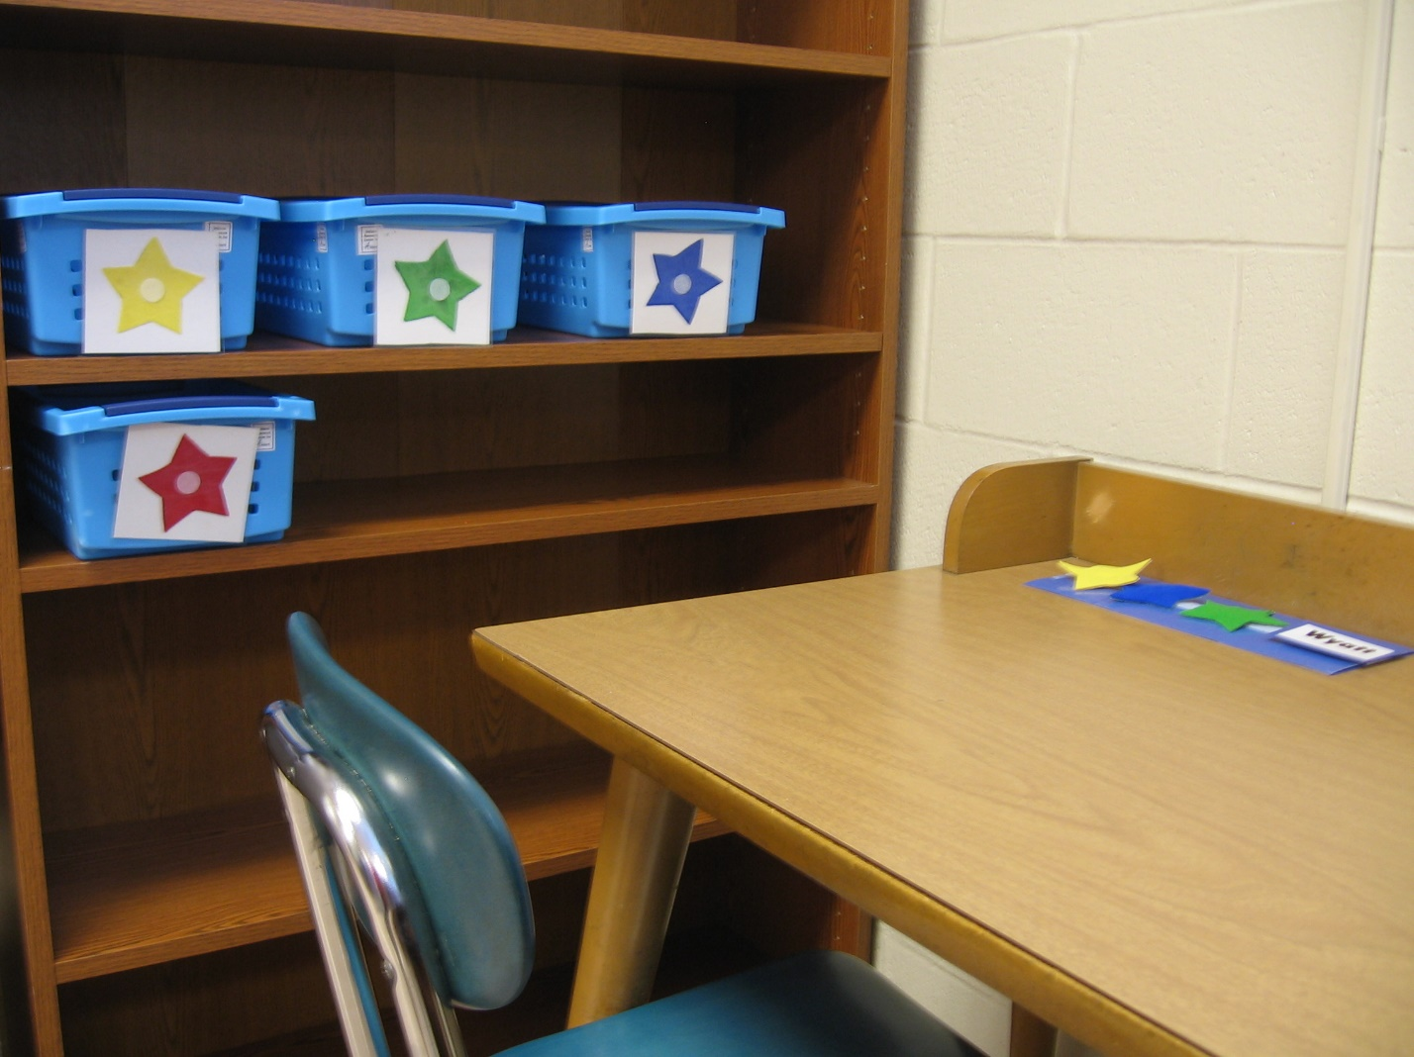
Category: Work Systems
Description: Colored stars are set up by staff on strip on student desk. Name card that tells student to go to schedule is placed at the end of the stars. Student pulls off each star and matches it to the same color star on a work task on his left. Then complete that task. After completing all tasks student goes to schedule and moves on to the next activity. Function: independent completion of several tasks.

