December 2021
Sunday | Monday | Tuesday | Wednesday | Thursday | Friday | Saturday
 |  |  | 1 | 2 | 3 | 4
5 | 6 | 7 | 8 | 9 | 10 | 11
12 | 13 | 14 | 15 | 16 | 17 | 18
19 | 20 | 21 | 22 | 23 | 24 | 25
26 | 27 | 28 | 29 | 30 | 31
January 2021
Sunday | Monday | Tuesday | Wednesday | Thursday | Friday | Saturday
 |  |  |  |  |  | 1
2 | 3 | 4 | 5 | 6 | 7 | 8
9 | 10 | 11 | 12 | 13 | 14 | 15
16 | 17 | 18 | 19 | 20 | 21 | 22
23 | 24 | 25 | 26 | 27 | 28 | 29
30 | 31

Hanukkah  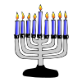 | Hanukkah | Hanukkah | Hanukkah | Hanukkah | Hanukkah | Hanukkah
Christmas Eve | Church  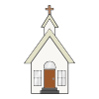 | Christmas Day | Christmas Day  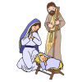 | New Year’s Day | New Year’s Eve | Hanukkah
Kwanzaa  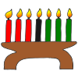 | Kwanzaa | Kwanzaa | Kwanzaa | Kwanzaa | Kwanzaa | Kwanzaa
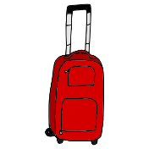
Travel  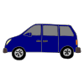 | Travel | Travel | Travel | Travel | Travel
No School  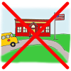 | No School | No School | No School | No School | No School | No School

School Day  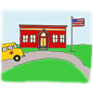 | School Day | School Day | School Day | School Day | School Day | School Day
Snow Day  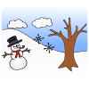 | Snow Day | Snow Day | Snow Day | Snow Day | MLK Day
e-Learning Day | e-Learning Day | e-Learning Day | e-Learning Day | e-Learning Day | e-Learning Day | e-Learning Day

