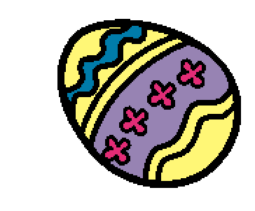 | Easter is a holiday that is celebrated every year. Easter is celebrated in the spring. Sometimes Easter is in March and sometimes Easter is in April.
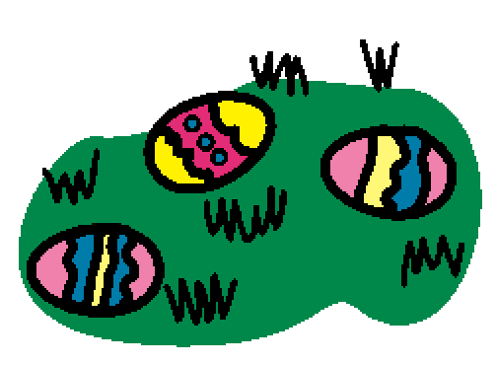 | Some people celebrate Easter by going to church. Some go to Easter egg hunts. Some people celebrate Easter by having a family dinner. Other people do not celebrate Easter.
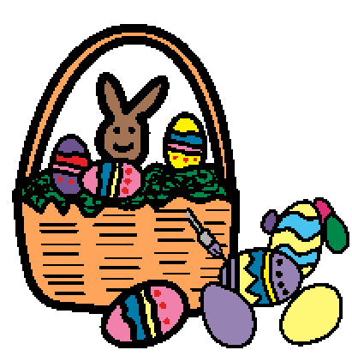 | Some people celebrate Easter with baskets. Some celebrate by coloring eggs. Sometimes people have Easter parties or parades.
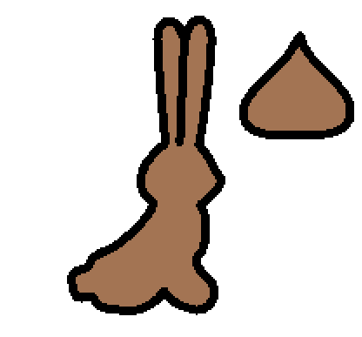 | Some people like to eat Easter candy, like jelly beans or chocolate. Easter is a happy and fun holiday every spring.

