 | Sometimes we have drills. We have drills to teach us what to do if there is an emergency. We practice ways to stay safe. We practice staying safe at school and at home.
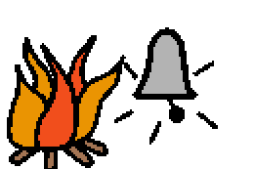 | One drill that we practice at school is a fire alarm. We practice safe to get out of a school or a house if there is a fire. We have fire alarms to make noise if there is a fire or a drill.
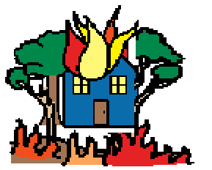 | If there is a real fire, people might smell smoke or see flames. Sometimes people will only hear the fire alarms or smoke detectors. The noise may be loud so that people can hear. Some people have to cover their ears.
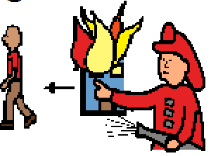 | When a fire alarm or smoke detector makes noise, it is a good idea to go outside and have someone to call 911 for the fire department to help. The fire fighters will help put out the fire and help everyone get outside safely.
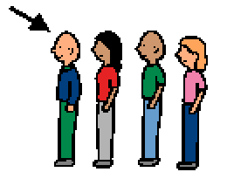 | During a fire drill, we practice how to go outside safely. At school, we line up and go outside calmly with a teacher or an adult. We walk quietly when we practice.
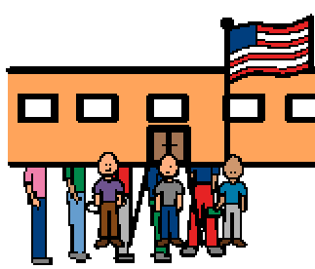 | During a fire drill, a teacher or an adult will take the students outside to wait. When the drill is over an adult will say “all clear” or that the drill is “over”. Then we will walk back to class.
 | Remember, we have fire drills to practice safe ways to get out of a school or house if there is a fire. When we practice, there is not a real fire. We practice to stay safe.

