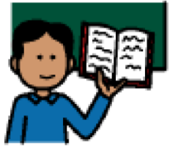 | Wait for the teacher to finish speaking.
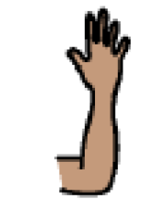 | Raise your hand without waving.
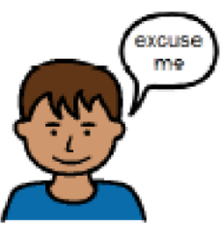 | Get attention by using the expression, “Excuse me.”
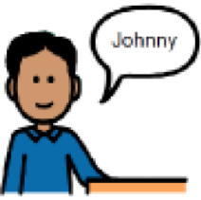 | Wait for the teacher to call on you.

