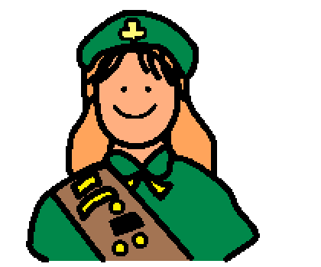 | I am a Scout! I go to Scout meetings to have fun and to learn new things.
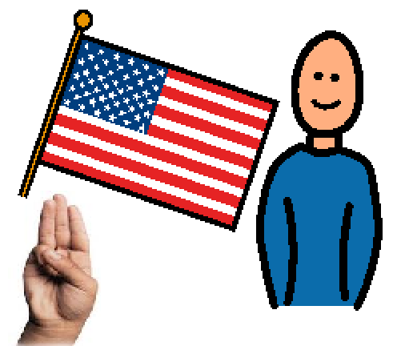 | At my Scout meetings, I will say the Pledge of Allegiance to the Flag and the Scout Pledge.
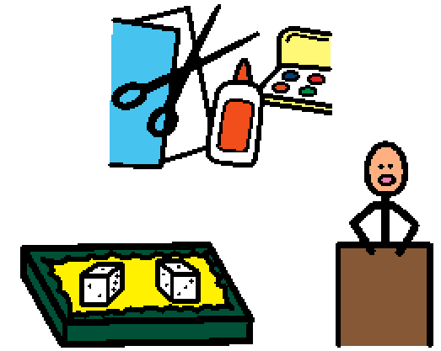 | My troops will also do an activity. Sometimes we will learn something new. Sometimes we will do a craft or art. Sometimes we will play a game or go on a field trip.
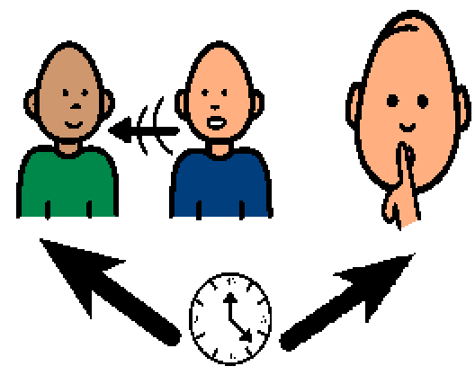 | There will be times when I can move and talk to others. There will be times when I have to sit and be quiet. My mom and dad or scout leader will help me to remember the rules.

