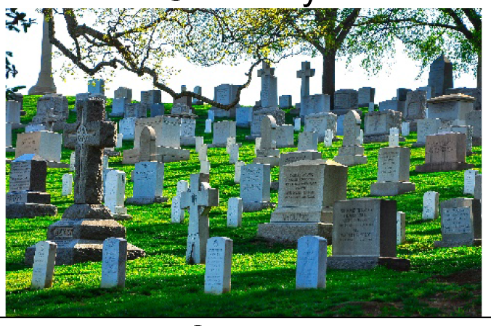 | After the funeral service is over, the casket will be put into a hearse. A hearse is a special car that carries the casket. I will get into my car and follow the hearse to a cemetery. A cemetery is an outside place where caskets are buried.
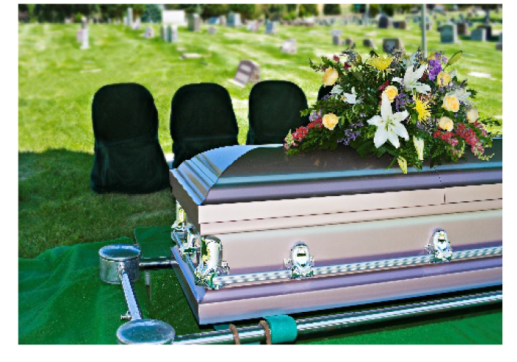 | People may say prayers and talk more about my special person who died. I will sit quietly when people are praying or talking. After people are finished talking, sometimes the casket is lowered into the ground. Sometimes, this is done after all the people have left the cemetery. I will remember that my special person’s body has stopped working and cannot see, hear, or feel anything.
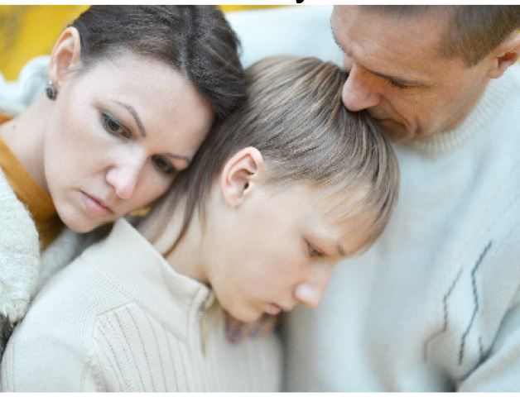 | I will get back into my car. Some families go out to lunch, dinner or may go back to a church or temple for food. Some families will just go home. When I go home, I might feel sad, mad, confused, or tired. I can tell my mom, dad, or favorite adult my feelings if I want to. All of my feelings are OK.
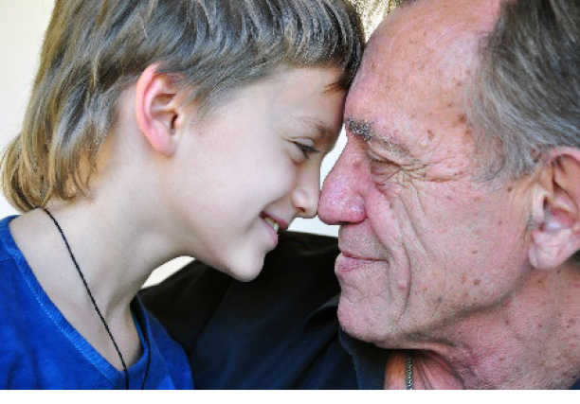 | I can think of the fun times I had with my special person. Soon I will feel better and be happy again. I know my special person will always love me and I will always love them. I will be OK!

