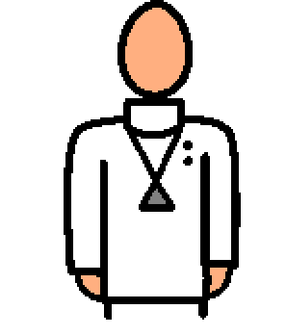 | I am going to the eye doctor. The eye doctor is also called optometrist. The eye doctor helps me take care of my eyes. The eye doctor is nice and wants to help me. Everyone has to the eye doctor to have healthy eyes.
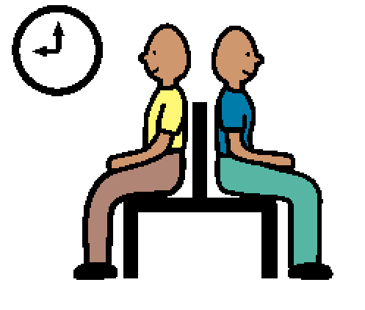 | When I go to the eye doctor, I will wait in the waiting room until the assistant says my name to tell me it is my turn. There are usually televisions or magazines and some games in the waiting room. I can read or play while I wait. Then I will go to the examination room to sit in a big chair and wait for the doctor.
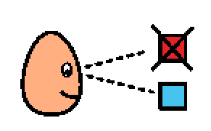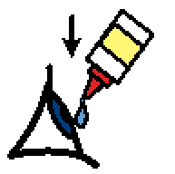 | The doctor will look in my eyes with a special light. The assistant may help the doctor test my eyes. I might look at pictures and choose colors for the doctor. I might look at letters and numbers on the wall. I might have to have a puff of air or eye drops. The doctor wants to make sure my eyes are healthy and that I can see. I need to try to do what the eye doctor asks me to.
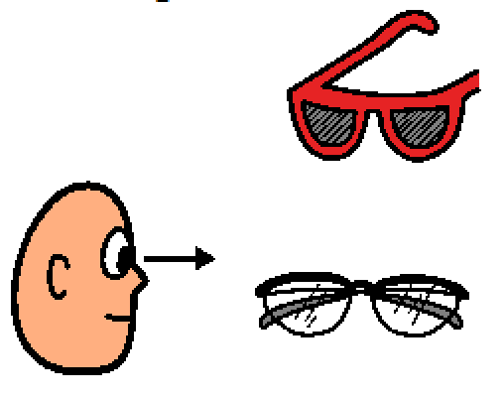 | If my eyes are ok and I don’t have any trouble seeing, I won’t need glasses or contacts. The eye doctor might ask me to wear special sunglasses to keep light out of my eyes for a few hours after my visit. If I have trouble seeing, I might need glasses or contacts to help me see better.

