Holiday Gifts

When we celebrate the holiday, I will be giving and getting gifts. Another word for a gift is a present. It is important to wait to open my presents. My parents will tell me when it is okay to open a present. I may need to take turns opening presents.
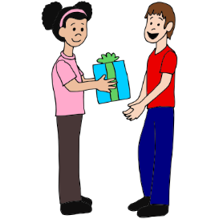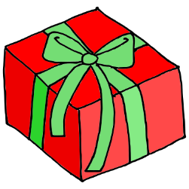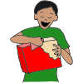
I can check the label or card to see who the present is from. It is good to say “thank you” to the person who gave me the present. If I already have the present or do not like the present, it is polite to just smile and say, “thank you.” Saying that I do not like the present may hurt the feelings of the person who gave me the present.
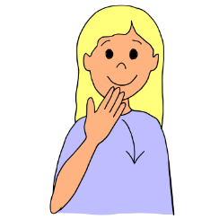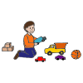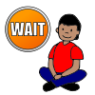
After I have opened my presents, I can ask mom or dad if I can play with or use my new present. I may need to wait until later or I may be able to play right away. It is fun to get and give presents. Other people feel happy when they get presents too.
