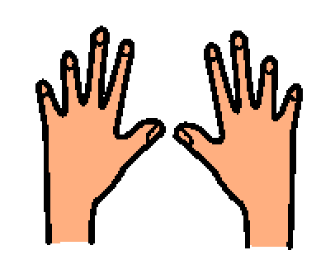 | People use their hands to touch and feel. Hands touch a lot of things every day, like toys and tools and food and pets. People touch their own skin, too. I try to keep my hands calm, especially when I need and want to touch my skin a lot. Touching a lot may mean rubbing or picking at my skin.
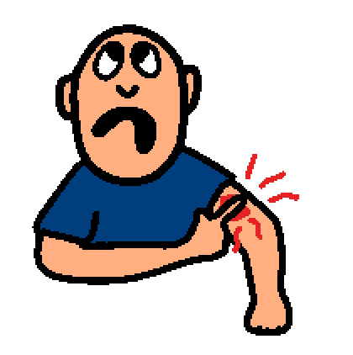 | It is not a good idea to pick my skin. If I touch and pick my skin too much. I can hurt myself. Picking can make sore places. It is not a good idea to make sore places. I can try to think keeping my hands calm. I may need to keep my hands busy, so my skin can be healthy.
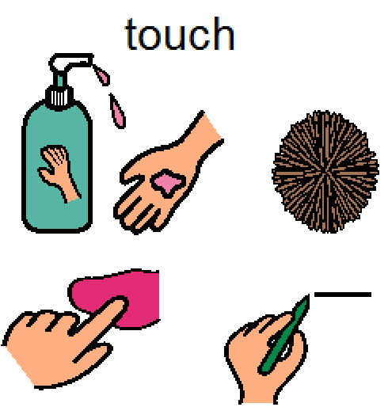 | I don’t want to hurt myself so I make good choices about what I am touching. I can try to put lotion on after I shower to calm my skin. I can also remember to rub my skin with a towel after I shower. I can also try to think about other things that I like to do. I can try to squeeze my hands together or touch a toy or a fidget instead. I can draw or create art with my hands.
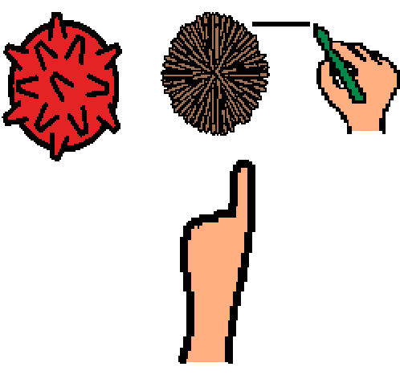 | I try to keep my hands busy and keep my skin healthy and happy. Being healthy and safe means making good choices. If I want to pick my skin, it is a good idea to choose a fidget and to calm my body and keep my hands busy. It is important for me to stay safe and healthy.

