Jigsaw Puzzle Activity
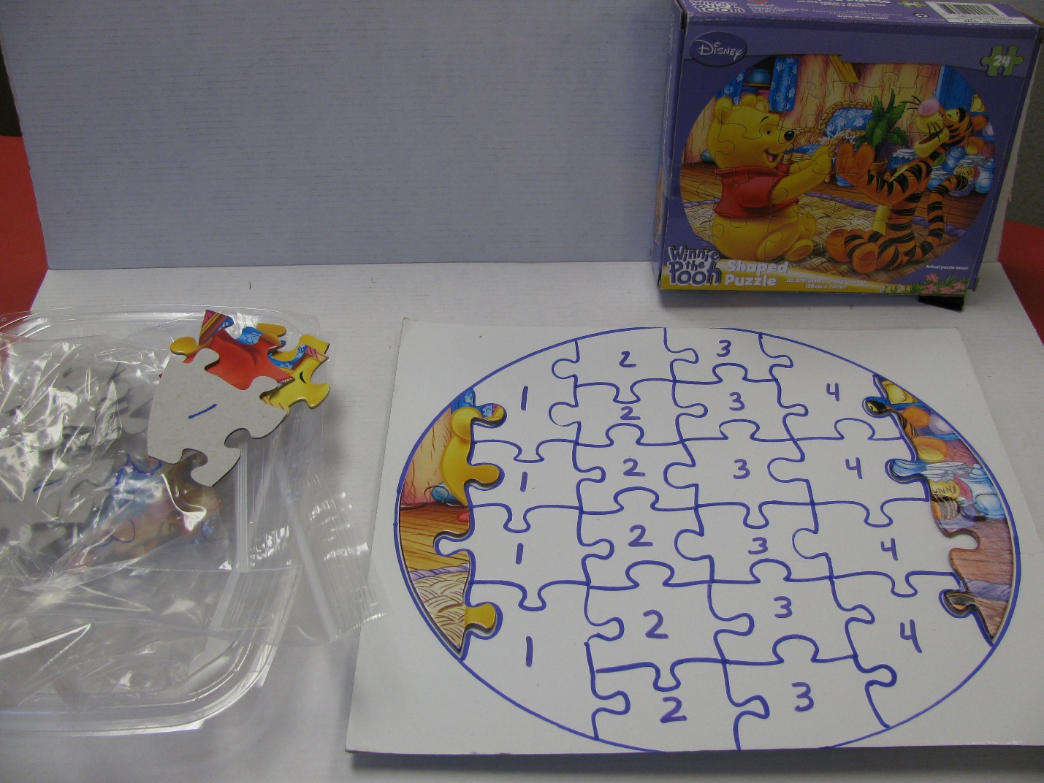
Category: Structured Tasks
Description: Puzzle is structured and simplified enabling independent completion by numbering back of each piece and outlining numbers on corresponding board. Baggies are used to organize the pieces (e.g. all pieces labeled ‘1’ are in bag 1). Can be completed independently or as a paired activity with each student completing a line of pieces. Function: independent leisure skill.

