Lego Activity Boat
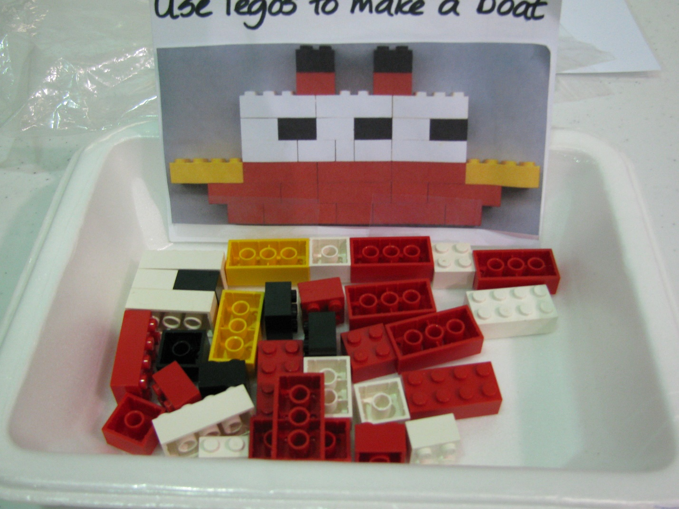
Category: Structured Tasks
Description: Photo of completed boat is stuck to Styrofoam tray and activity is presented to student with Legos in the tray. Function: independent leisure skill.

