Lego Activity Difficult
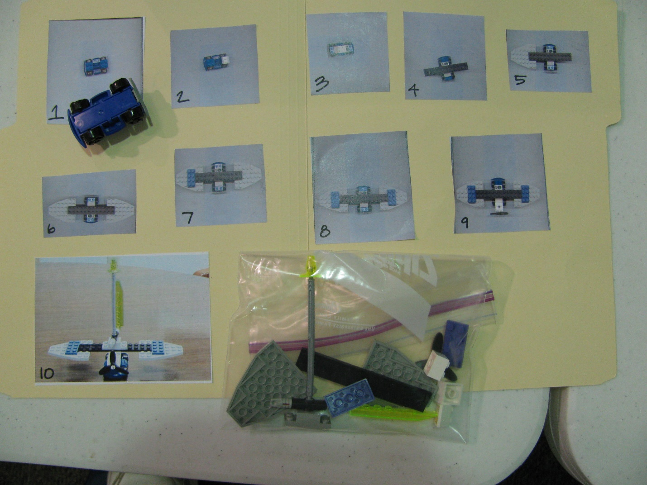
Category: Structured Tasks
Description: Photos of the steps of making the vehicle are stuck to a file folder. Lego pieces are organized in bag stapled to same folder. Function: independent leisure skill.

