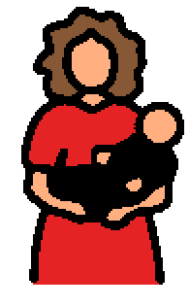 | Mother’s Day is a holiday that is celebrated every year. Mother’s Day is celebrated on the second Sunday in May. Mother’s Day is a special day for moms and women.
 | Sometimes children give their moms gifts. Sometimes dads help and give their wives gifts too. Some people give cards. Some people give flowers. Some give a special gift like candy. Some plan a special day with fun activities or events.
 | Besides moms, other women to celebrate can be grandmothers, great-grandmothers, stepmothers, foster mothers, and women who are like moms.
 | It is a good idea to make a card or give a gift to your mother or to a woman who is like a mom. Saying thanks and doing something kind makes other people feel happy. Celebrating Mother’s Day means celebrating love and family.

