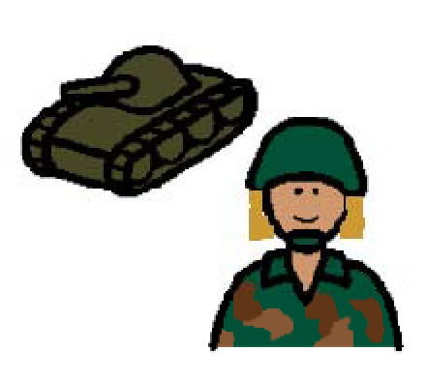 | My Mom is a soldier. She has a very important job.
 | Sometimes doing her job means she has to go away from home.
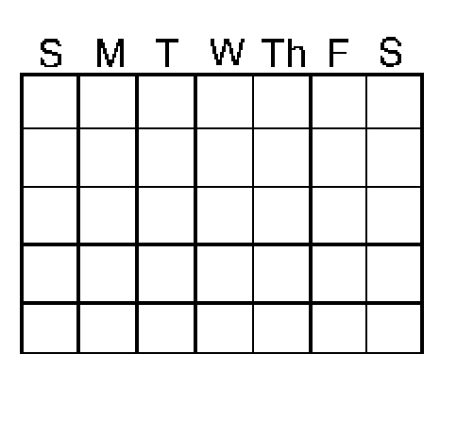 | Sometimes she is gone for a few days. Sometimes she is gone for months.
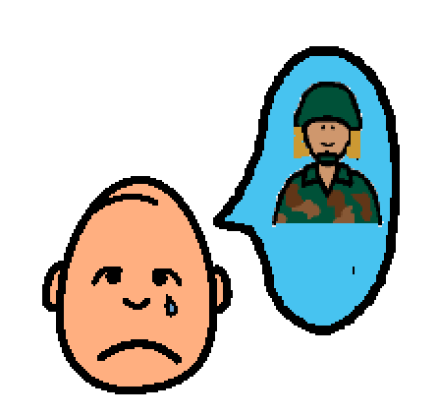 | I miss her when she is gone.
 | Sometimes I get sad when Mom has to leave. That is OK.
 | Mom is sad to leave me too. It is OK to be sad.
 | Sometimes I get angry when Mom goes away because I want her to play with me.
 | That is OK. When I get angry or sad, I can try to write Mom a letter or draw her a picture.
 | That will help me remember Mom and feel like she is closer to home.
 | That will make me feel better.
 | I know Mom loves me even when she’s not here.
 | I know Dad loves me too.
 | I will try to be brave when Mom is not here.
 | I will look forward to Mom coming home.

