 | At my school, students say the Pledge of Allegiance in the mornings. We say the Pledge because we are proud to live in the United States of America.
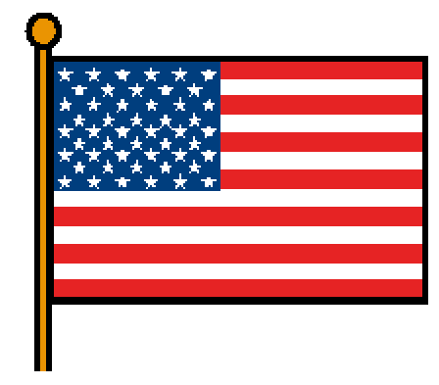 | The Pledge is to our country and our flag, because the flag is a symbol of our freedom in America. We do not have to say the Pledge, but we try to be quiet and stand still during the Pledge. We try to wait quietly for the Pledge to be finished. We may need to be quiet for a little more time afterwards.
 | To say the Pledge of Allegiance, we put our right hand over our hearts and say, “I pledge allegiance to the Flag of the United States of America, and to the Republic for which it stands, one Nation under God, indivisible, with liberty and justice for all.”
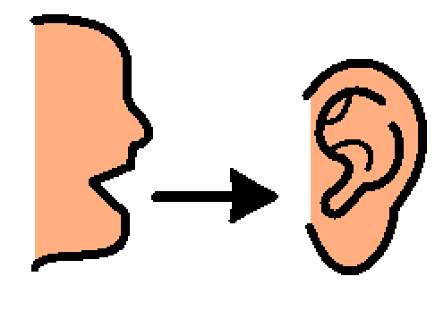 | We remember that it is the rule to be quiet and stand still during the Pledge. We try to do our best to follow the rules. When the Pledge of Allegiance is over, we listen to our teacher so we know what to do next.

