Unavailable

There may be some things that I want but I can’t get right now. These items are unavailable. It is taking a longer time than usual for stores to get some toys, food, and other items to sell. It is taking an extra-long time for the boats and trucks to bring the items to the stores. It may take a longer time for the items we order online to be delivered to our house.
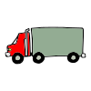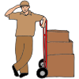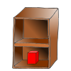
I might feel sad or frustrated that something I want is unavailable. When this happens, I have two choices. I can wait for the item or I can choose something else. I can ask how long the wait is for the toy I want. It may be a few days. It may be a few weeks. If I choose to wait for a toy, I can play with my other toys until the new one arrives. If it’s going to take a really long time and I don’t want to wait, I can choose to get a different toy.
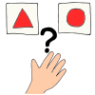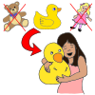
There may be food that I like that the grocery store is all out of. I can wait and try to get that food another day, or I can choose a different food to try. It’s good to try new things. I might like them too.
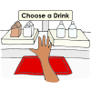
I know that sometimes things I want are unavailable. I will make a choice to wait or get something else. I can ask my family for help if I’m not sure which choice to make. My family will be proud of me for making a choice.

