During puberty, I may grow taller.
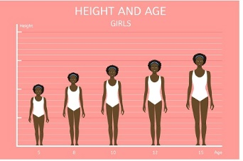

I will try to wear an undershirt or a sports bra so my breasts are comfortable.

I may grow hair under my arms in my armpit. I will try to remember to put deodorant on my arm pit so I can smell clean and pretty.
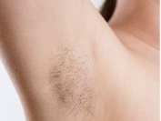

I may get acne. I will try to wash my face with soap and water one time a day.
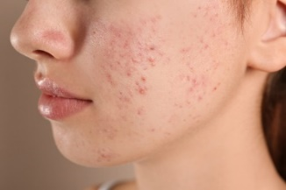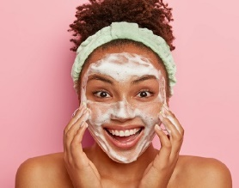

I will try to wash my body and wear clean clothes every day. I will do my best to take care of my body during puberty to be healthy.

