 | People like to be safe. Being safe means that we try not to get hurt. There are a lot of ways to be safe. Following rules and making good choices helps us to stay safe. Parents and teachers want kids to stay safe at home and at school.
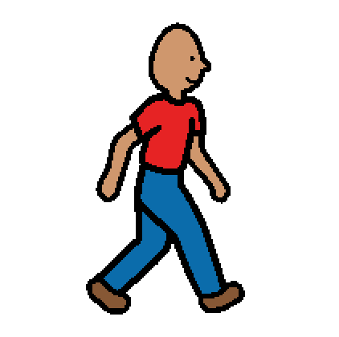 | When people are upset, they may feel like running away. It is not a good idea to run away at school or at home, because it is not safe. It is a good idea to STOP and stay safe. To stay safe, go to a safe place inside and calm down. Running away scares parents and teachers.
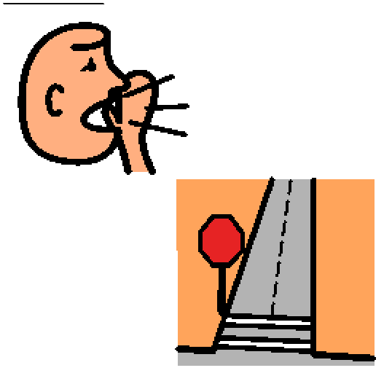 | If someone yells “STOP” or if there is a STOP sign, people are supposed to stop and stay safe. Remember to try to calm down and make good choices. Parents and teachers can help.
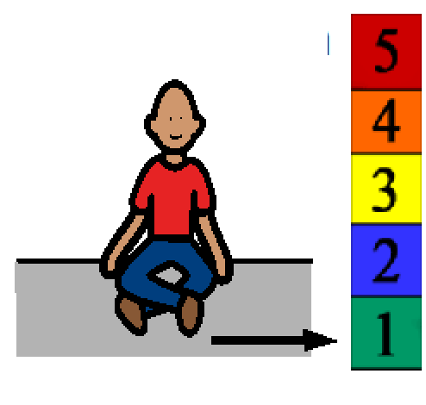 | It is a good idea to go to a safe or quiet place inside to calm down. Running away is not safe and is against the rules. Parents and teachers want kids to stay safe at home and at school.

