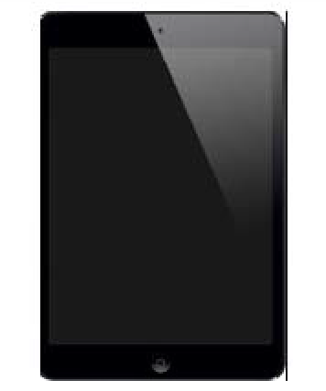 | My school has iPads for students to use for learning. The iPad is a fun way to learn. We remember that we have to be careful and take good care of the iPad we are using.
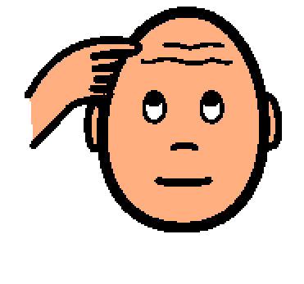 | Students should remember that the iPad does not belong to them. The iPad belongs to the school. Students should follow school rules and remember that school property has to be used carefully. The teachers trust us to take good care of the iPad.
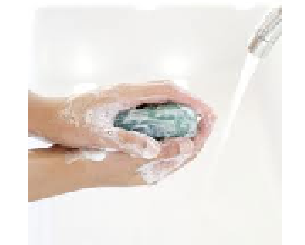  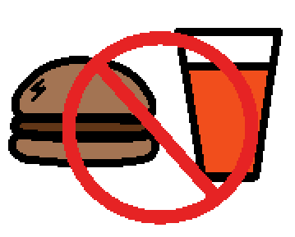 | To take good care of the iPad, we remember:  1. The teacher gets to choose the settings and apps.  2. Follow the teacher's instructions when using iPad.  3. Do school work first. Don’t play games during work time.  4. Keep the cover on the iPad when it is not being used.  5. Keep hands clean and keep the iPad clean.  6. Keep the iPad away from food and drinks.
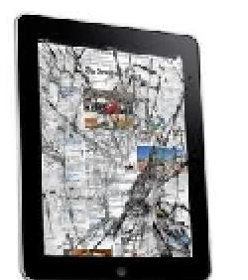 | Students should be careful to take care of the iPad and try not to bang, bump, or drop the iPad on the floor or against objects. It is fun to use the iPad to learn and we won’t be able to use the iPad if it is broken.
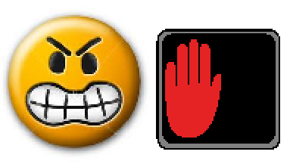 | If the iPad is broken, it won’t work. Teachers and parents will be unhappy because a broken iPad costs a lot of money and time to fix. If students get angry when using the iPad, they can put the iPad on their table or desk and wait until they are calm. Remember to take good care of the iPad.
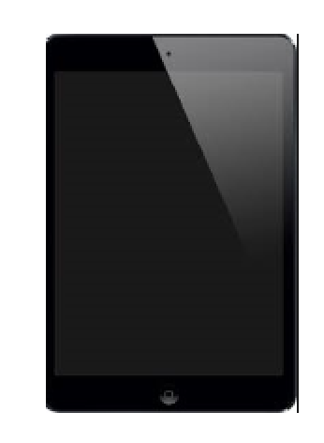 | Using the iPad makes learning fun. Students need to do their work first and follow the rules so they can continue to use the iPad at school. It is important to do good work and to learn at school.

