House  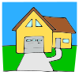 | Some people live in a house or an apartment. Some people live in a condo. Some people share a house. Some people stay in hotels or other places to sleep.
Apartment  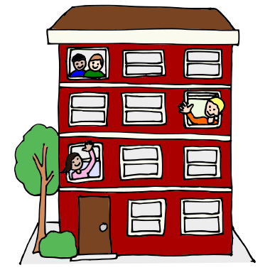 | Sometimes people move to a new place to live. They may need a bigger place or a smaller place. They may need to move in with other people. They may need to live closer to school or work. Some people change where they live to save money.
2 homes  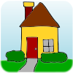  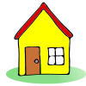 | Sometimes people live in more than one place, like when moms and dads don’t live together. Kids may live with mom at one home and dad at another home. Or when people have a home and a vacation home, too. People might stay at the vacation home during holidays or vacations or on weekends.
Pack  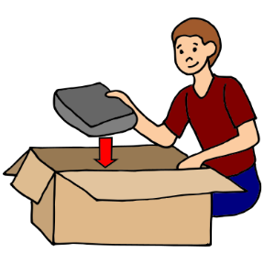 | When people move, they pack their things in boxes and move their things to the new place where they will live. It takes time to move. It is a change, but it is okay. Living in a new place means getting to have a new room and meeting new people too.

