Wearing a Bra
During puberty, all girls’ breasts start to grow. At first, they look like little bumps or mounds under the nipples called breast buds. The girls breast buds can feel tender and sometimes rub under your shirt which can be uncomfortable. Wearing an extra layer of undergarments can protect one’s breasts and feel more comfortable. An undergarment is also called a camisole or undershirt.
Another type of undergarment is called a bra. Bras come in many styles and colors.
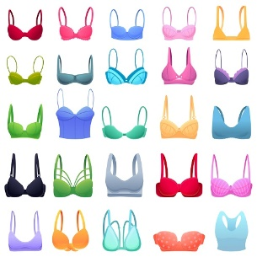
Your mother may suggest you start by wearing a sports bra. Sports bras are comfortable, and you can slip it on over my head.
Sports bras come in many different colors too. Your favorite color is ____and you can add a favorite character as a patch on your bra or add rhinestones.
Wearing a sports bra during sports will provide support for your breasts too. As breast mounds get bigger, you can continue to wear a sports bra or get measured for a regular bra that feels comfortable. Try to wear a bra under your clothes every day to support your breasts and help you feel comfortable.

