Which Snack? Object Communication Board
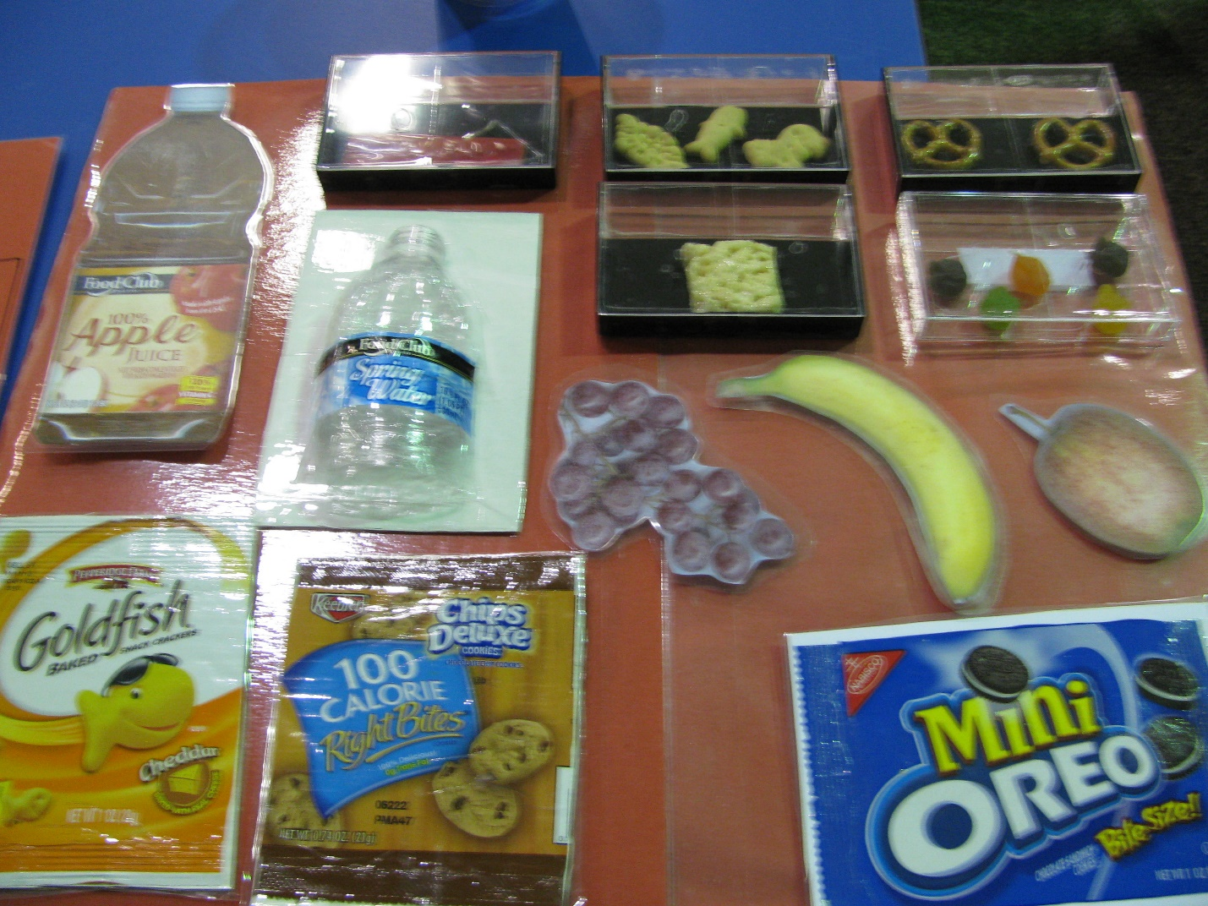
Category: School
Description: Student pulls items off board and hands them to teacher to request snack. Board is combination of objects, real packages, and photos (omit photos for a student who is only recognizing objects). Function: teaching student to communicate wants and needs.

