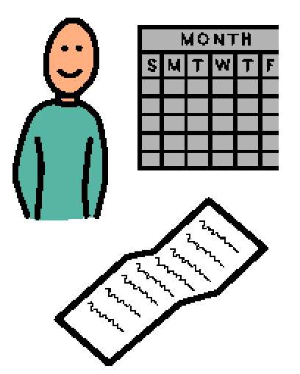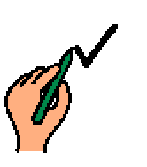 | I have a calendar and a schedule at school. My calendar tells me when I have school and when I am on a break. When I am at school, I try to use a schedule. My schedule is a list of what activities I am doing and what next. I can check off activity when I am finished.
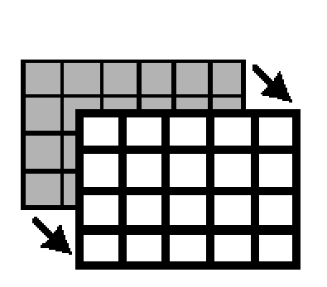 | I can look at my schedule to see what is next. If I do not like what I am doing now. I can remember that the activity will end soon and I will get to do different activities too. Sometimes my schedule will change. An adult will tell me if there is a change and what is happening. Sometimes the change is a very good change, like a special snack or event.
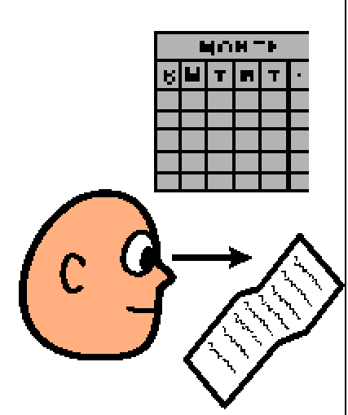 | Sometimes the change just means I will be doing a different activity or that there is a change to the time of an activity. A change may mean a vacation day or a sub. Changes are okay. I can look at my schedule to see what is happening next. My schedule helps me to know what I am doing so I can learn.

