Written Work System Elementary Student 2 of 2
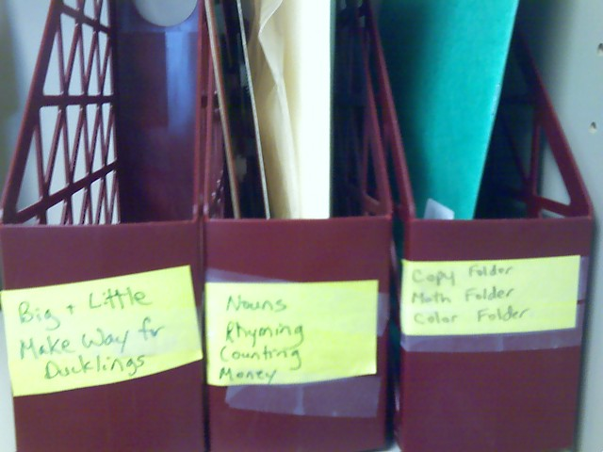
Category: Work Systems
Description: Boxes containing the activities to be completed have same labels as student’s written list.

