Written Work System for Adult 2 of 2
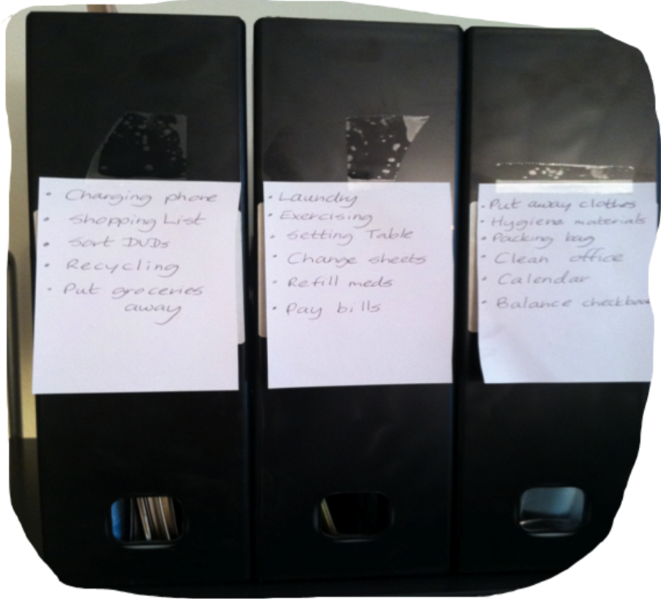
Category: Work Systems
Description: Boxes containing the activities to be completed have same labels as the learner’s written list.

