My Bedtime Routine

All Done
Pick up toys
Brush Teeth
Go Potty
Put on pajamas
Read Story
Get in Bed

How to use: Edit this Bedtime Routine to fit your needs. Place the picture in the left column to show you child what needs to be done. When the activity if finished, have your child move the picture to the right “ALL DONE” column.

Pictures for Bedtime Routine
Pick up Toys  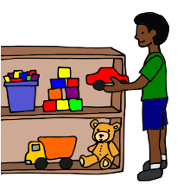 | Brush Teeth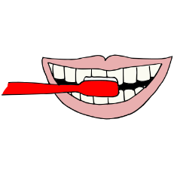 | Potty  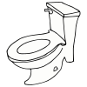
pajamas  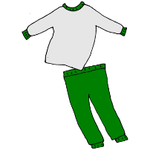 | book | bedtime  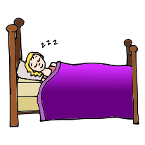
Clean Up  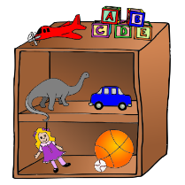 | Medicine | Bath  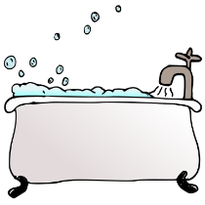
Hugs  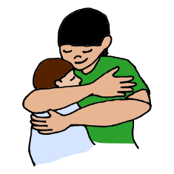 | Teddy bear  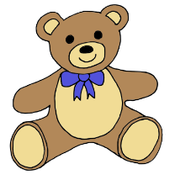 | blanket

